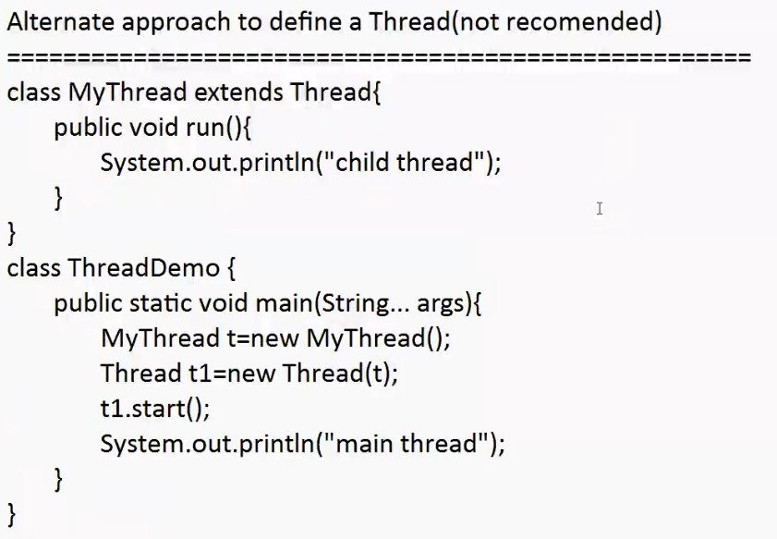

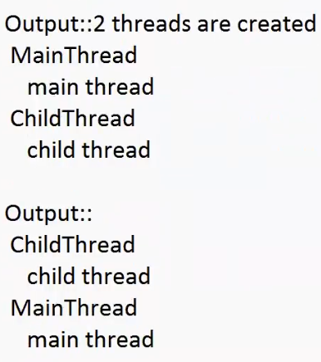

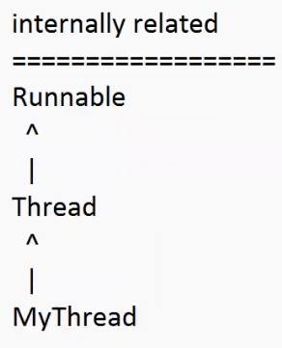

Eg: Alternative_Approach_For_Thread_Creation

// go through the code

* It is possible to change the name of the thread using setName()
* It is possible to get the name of the thread using getName()

Methods :

public final void setName(String name)

public final String getName()

Eg: Modify_Name_Of_Thread

// go through the code

Eg: Modify_Name_Of_Thread_Eg2

// go through the code

Note: we can set the same name to multiple threads, but not recommended.